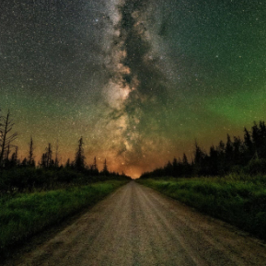
Northern Minnesota Recreation and Parks Association
Monday, April 25
11:00 AM

- Round Table/Introduction- Share a winter program that was successful, or you are most proud of.
  - Please limit updates to 2 minutes
    - Amber- City of Nisswa- Marketing- word of mouth, flyer to elementary schools, NextDoor App

- MRPA Updates- Working at getting Mandated Reporting pushed to next summer, will keep us updated with any new information

- Large Group Discussion- When implementing a new project, program, or event, how do you ensure it’s a successful one?

  - Programming Topic- Are there any current program trends that you would like to do? Are there any trends that you would like to stay away from?
    - E-Sports
      - Not Currently Offering, trying to keep kids away from screens
        - Mike-City of Rogers
      - Currently Offering
        - Sara- City of Monticello-Doing E-sports, GG Leagues, incorporates parent education and promotes collate scholarships
        - Warren- City of Elk River & Lee-City of Buffalo- Doing E-sports
    - Pickleball
      - Sara-City of Monticello- pickleball, would like to add a youth program/league

    - Drones in the Parks
      - Sara- City of Monticello-anyone offering programs or classes?
      - Mike- City of Rogers- a few complaints about drones’ races in the parks, not following rules and ending up in people’s yards
      - Warren- City of Elk River- Marketing Department uses drones, does videos at the skatepark
    - Skateparks
      - Who has one??
        - City of Elk River
        - City of Buffalo- old needs some replacing, has cameras in the park
        - City of Hutchinson
        - City of Big Lake- needs a remodel, community loves
        - City of Otsego- needs an update
        - City of Elk River- working with 3rd Lair for programming
        - City of Bemidji
- Anything Else & Upcoming Meeting – May meeting hosted by Nisswa, any future topics like to discuss?

https://3rdlair.com/pages/camps
Pump tracks . . . if interested in visiting with other agencies, I think Plymouth and Saint Charles may have pump tracks.

