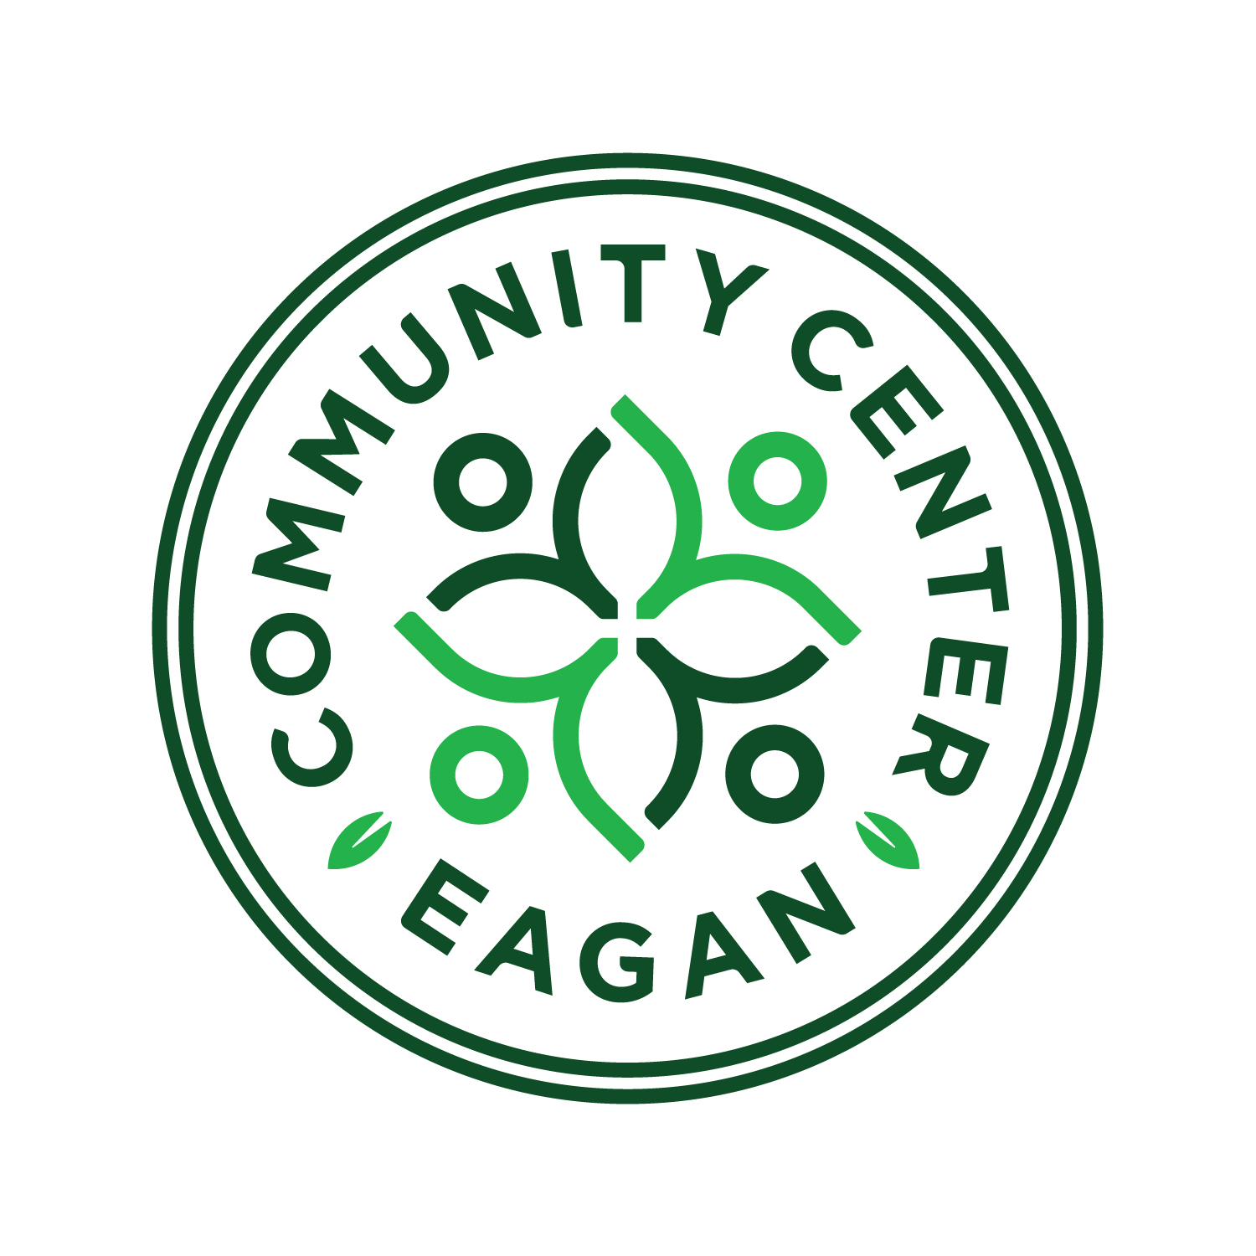

CITY OF EAGAN
EAGAN COMMUNITY CENTER

POSITION TITLE: Facilities Coordinator (Emphasis: Outreach, Facility Programs & Special Events)
DEPARTMENT: Parks and Recreation
REPORTS TO: ECC Manager
FLSA: Non-exempt, Grade 8

OVERVIEW:
The Facilities Coordinator responds to the needs and concerns of all facility users in a courteous, informed, and enthusiastic manner including scheduling users and groups at the Community Center, processing detailed information, completing data entry for facility use requests, record-keeping and financial reporting for the rental process. The Facilities Coordinator is required to perform all tasks necessary to assist members and guests and to oversee and assist in functions that make the facility more attractive, presentable, and rentable.

The Facilities Coordinator will provide supervision to part-time employees and ensure that staff is executing high level customer service that meets the policies and standards of the Parks and Recreation Department.

ESSENTIAL POSITION DUTITIES AND RESONSIBILITIES:

PROGRAM COORDINATION & FACILITY OPERATIONS
- Arranges for and schedules use of all Community Center facilities, including but not limited to banquet and meeting rooms, gymnasium, performance center, gazebo and bandshell, for both individual and program activities through computerized scheduling system; issues facility use permits to customers.
- Provides and obtains relevant information for facility rental. Tour prospective customers, prepare invoices and receipt payments in conjunction with other Facility Team members.
- Coordinate all rental requests by customers including food and beverage, room setup diagrams and A/V equipment.
- Lead the set-up and coordination of audio and visual equipment for events.
- Oversee the daily event schedule to ensure proper room setups and customer needs are met in a timely fashion including communication of information to part-time staff.
- Communicate meeting and event set-up details with contracted caterers to ensure quality service.
- Supervise (coordinate, lead, and assist) in the scheduling of room setups, food & beverage operations, guest services counter, recreation programs, fitness center or other areas as necessary for community center operations.
- Responsible for collection of deposits, payments, issuance of refunds and invoices for facility rentals and food/beverage services.
- Develops, maintains and forwards reports to the Community Center Manager on a regular or as needed basis regarding facility use, food/beverage service, equipment or other provisions charged to the facility user.
- Lead and assist in the coordination of events and logistics for Department events and program.
- Monitor the Eagan Community Center and Central Park (building and grounds) to maintain a clean and safe environment for all users.
- Monitor building equipment and inventory as needed or directed.
- Open and close the building as scheduled.

GUEST & CUSTOMER SERVICE
- Provide a positive physical presence in the building to sustain a high level of customer contact.
- Demonstrate and communicate the customer service philosophy of the facility and department to guests and staff to ensure cohesive messaging and service.
- Greet and assist customers on the phone, in person and via e-mail; provide tours and information to ECC customers as needed.
- Assist guests in the registration for recreational programs, classes and activities, and in the reservation of facilities where applicable.
- Facilitate the sale of prospective facility, event, and activity services including communicating rental information, fitness center/track/gymnasium use, and completing appropriate documents.
- Troubleshoot concerns that may arise with customers, members or any groups using the facility or grounds.
- Complete on-going facility program evaluations, injury reports, damage reports and equipment or supply request forms.
- Report incidents and information to necessary supervisor, maintain and update log books and online information.
- Keeps Community Center Manager and other management staff informed of daily problems, new developments, work accomplishments and status of operation.
- Responsible for deposits, receipts and monies associated with registrations and cash register transactions.
- Monitors expenses and revenues. Gathers requested data and statistics, tracks equipment and supplies and costing, performs inventory control and purchasing duties as needed or directed.
- Perform other duties as assigned.

PHYSICAL REQUIREMENTS:
- Lead staff in performing light maintenance including, but not limited to, room set-up/take-down and general cleaning (windows, indoor playground, floors, spills, tables, chairs, vacuum carpeted areas, clean surfaces in rest rooms and locker rooms, wipes down fitness equipment, restock paper products, pick up outside litter and snow removal when needed.)
- Must be able to list/move 50 pounds
- Must be able to stand and work for long periods of time.
- Use fine motor skills and manual dexterity to type and write, frequently using repetitive movements.
- See and read documents, correspondence, and computer screens.

Supervision of others:
- Provides recruitment and supervision to seasonal and part time recurring staff, contractors, volunteers, participants, and vendors.

Work Hours:
Hours of work will include evenings, weekends, and holidays. The position may require periodic changes to the schedule based on the demands of special events, facility schedules, and department efforts. The Eagan Community Center is a facility that is open to the public from 5:00 a.m. to 9:00 p.m. with expanded hours relating to private rentals/special events.

Anticipated Core Hours: Wednesday-Sunday; 8:30a-5p.

Minimum Requirements:
- Must be at least 18 years of age
- Associate’s Degree
- Three years direct customer service experience in a highly visible and active environment
- One year experience supervising or providing work direction to part-time staff
- Experience in executing/facilitating space rentals
- Experience working in a recreation facility, hospitality/events industry, or similar field.
- Proficiency in Microsoft Office software programs
- Current CPR and first aid training and/or certification or the ability to complete within 90 days of hire
- Valid driver’s license
- One year experience working with facility or event scheduling software.

Preferred Skills, Knowledge and Experience:
- Bachelor’s Degree in a Recreation or a Parks and Recreation related field
- Certified Park and Recreation Professional (CPRP) Certification
- Experience supervising a public facility
- Two (2) or more years of supervisory experience
- One (1) year experience in an office setting

