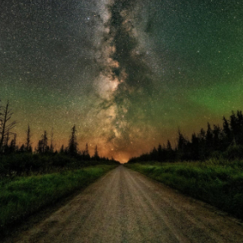
Northern Minnesota Recreation and Parks Association
Monday, May 16
11:00 AM

- Round Table/Introduction- Share a facility or park you would like to tour.
  - Please limit updates to 2 minutes

- MRPA Updates- Do we have a spot on the website and any ideas about dues??

- Group Discussions-

- What does everyone do for weekend building rentals for staffing and on call situations? What do you pay them?
- How does your city/department handle celebrations of life rentals at park shelters/pavilions?
- Does anybody have a “lost and found” program/policy/sign at any of your parks and buildings of they find an item not belonging to them?

- Anything Else & Upcoming Meeting –

